2018 Student Research Paper Awards
(Presented by CWSS Student Liaison Director, Scott Oneto)

($500) Katie Driver, University of California, Davis
Survey of Bearded Sprangletop Response to Clomazone in California Rice
($300) Alex Ceseski, University of California, Davis
Smallflower Umbrella Sedge Cross-Resistance to ALS Inhibitors in the California Rice-Growing Region
($200) HannahJoy Kennedy, University of California, Davis
Weed vs. Crop Differentiation Using Crop Marking Systems

($200) Diana Camarena Onofre, California State University, Fresno
Germination Rate and Glyphosate Resistance of Hairy Fleabane (Erigeron bonariensis)

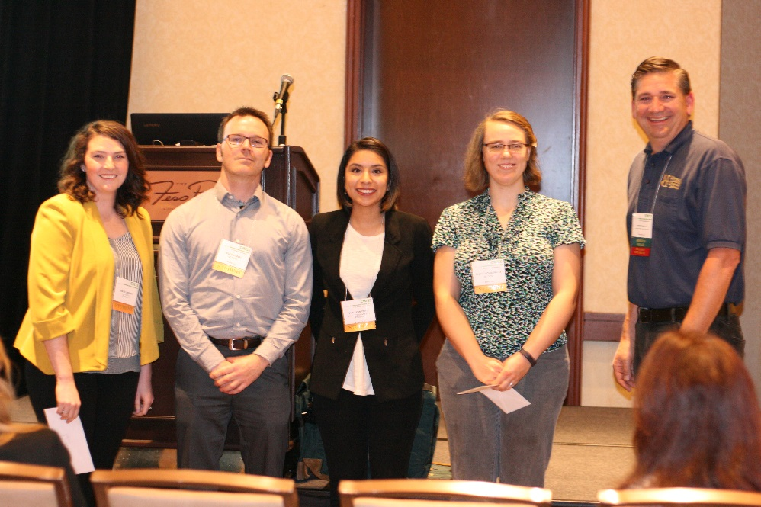
Katie Driver, Alex Ceseski, Diana Camarena, HannahJoy Kennedy and Scott Oneto

