2018 Student Research Poster Awards
(Presented by CWSS Student Liaison Director, Scott Oneto)

($500) Katie Driver, University of California, Davis
Bearded Sprangletop Adaptation to Flooding in California Rice

($300) HannahJoy Kennedy, University of California, Davis
Weed vs. Crop Differentiation Using Crop Marking Systems
($200) Priyanka Chaudhari, California State University, Fresno
Characterizing the Expression of Candidate Genes for Herbicide Resistance in the Agricultural Weed Hairy Fleabane (Erigeron bonariensis)

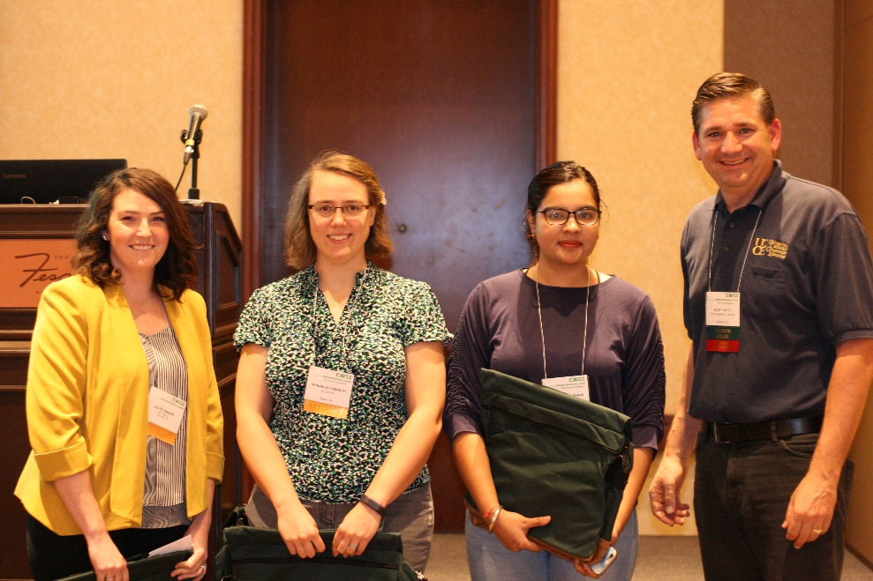
Katie Driver, HannahJoy Kennedy, Priyanka Chaudhari and Scott Oneto

